FUNdamentals (Ages 6-9 y.o.)

Remember – the use of a helmet is always recommended for young curlers.

Program Focus: FUN and Participation, Fundamental Movement Skills, Development of Relationships

On Ice Activities: Focus on developing balance on ice surface

Great Ideas:

- Moving Safely on the Ice:
Beginning Curlers will be using grippers on both feet for brushing. However, during the delivery they will be removing the gripper to deliver the stone. They will need to know how to safely return to a standing position and move around on the ice after delivering a stone.

Drill: Moving Safely on the Ice -
- Grasp the brush handle approximately at the mid-point with the non-dominant hand and place the dominate hand slightly lower on the handle.
- Place the head of the brush on the ice.
- Place the majority of the body weight on the sliding foot. The Curler can check that the sliding foot is under their centre of gravity by slowing lifting their gripper foot off the ice.
- Give a small push with the gripper foot and slide on the sliding foot. The brush is used as an aid to balance.
- Gradually give bigger pushes with the gripper foot and take longer slides.
- Have the Curlers move up and down the sheet until they feel comfortable.

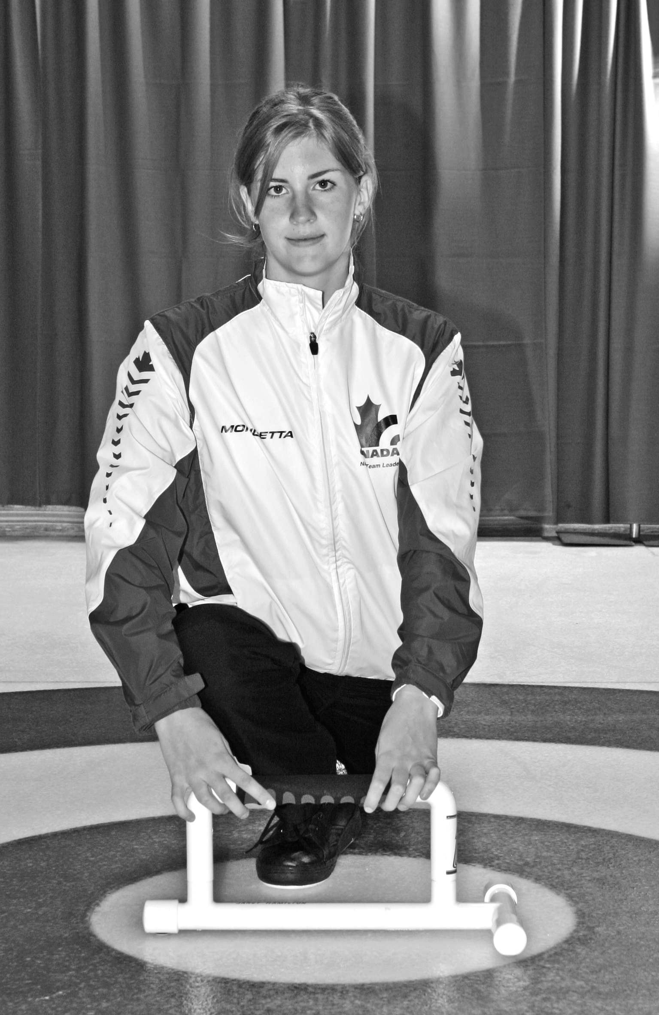
- Balance:
Using a stabilizer or crutch device turned sideways in front of the Curler, have the Curler execute slides. This drill will keep the Curler’s shoulders square and provide them with stability allowing them to get comfortable with the sliding foot position.
Variation: Do this drill with two stones in front of the Curler. Have the Curler slide forward keeping the two stones touching – this will also help strengthen the hack leg of the Curler!

- Movement on Ice in Slide Position:
Have a Curler extend into the final slide position while a partner places their brush on the small of their back and gently pushes them down the ice. Great opportunity for the Curler to find the correct brush and sliding foot position, while moving very slowly.
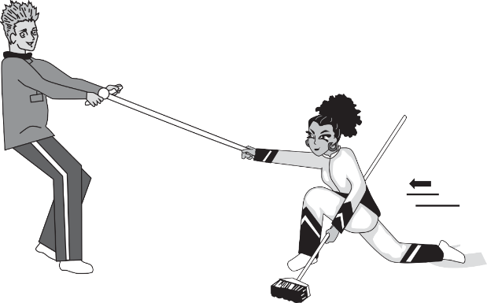
Variation: “Grab the Brush” -Curler can get into extended final slide position and reach for the brush of their partner in front of them. The partner can slowly (wearing two grippers) walk backward and pull the Curler down the ice, be sure to keep the brush head on the ice.
