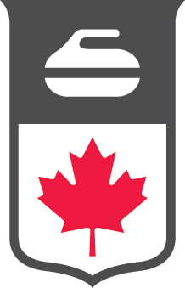

Curling Canada
Election for Positions on the Curling Canada Board of Governors Calendar of Key Dates for 2022 Election

 | PROCESS | DATE
1. | Call for candidates | July 4, 2022
2. | Deadline to submit candidates | July 29, 2022
3. | Deadline for incumbent candidates | July 29, 2022
4. | Candidates Search Committee review of candidates | August 2, 2022
5. | Governor Candidate interviews (all - including  incumbents) | August 3 – 12, 2022
6. | Candidates Search Committee recommendations to the Board (either slate or individuals) | w/o August 15, 2022
7. | Board approval of Committee recommendations (either slate or individuals) | w/o August 15, 2022
8. | Announcement of Candidates and invitation to  Member Associations for additional nominees | w/o August 22, 2022
9. | Additional candidates received | September 2, 2022
10. | Candidate Search Committee review of additional  candidates | September 9, 2022
11. | Finalization of list and recommendations sent to members | September 13, 2022
12. | Candidates’ CVs and videos forwarded through link for voting delegates’ review | September 13, 2022
13. | “Town Hall” for candidates (virtual) | September 22, 2022
14. | Election (conducted during virtual Curling Canada Annual Meeting) | September 24, 2022

