Active for Life

Program Focus: FUN, participation, involvement and recreation. Positive experience where athlete feels comfortable and safe.

On-Ice Activities: Reinforcement of fundamental delivery and brushing skills for positive experience. Modification of skills to ensure continued involvement.

Great Ideas:

- Line of Delivery

Use a string/yarn/ribbon to show the line of delivery. One Instructor holds the string in the middle of the hack. The other Instructor attaches the rope to a brush and stands in the house at the playing end. By moving the brush, the Instructors can show some of the variations in this line. Be sure to demonstrate the maximum deviation at the near hog line, for a target on the center line, at the 12 foot, the eight foot and the four foot at the playing end.

- Timing

The following is a drill that will help improve the sequence of a Curler’s delivery.
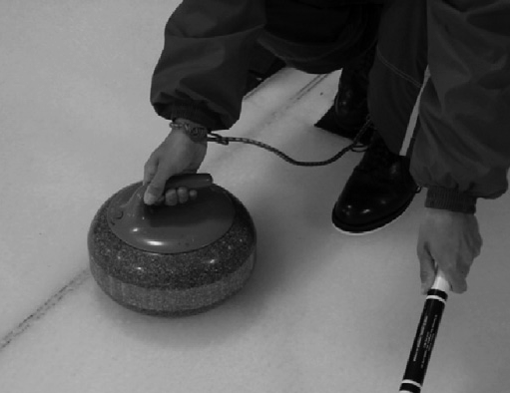
Using a bungee cord approximately 18-24” in length, attach one end to the laces of the sliding foot, and wrap and hook the other end around the throwing wrist of the Curler. The bungee cord will prevent the Curler from pulling their sliding foot too far back in the “Get Set” phase of the delivery, and it will prevent the sliding foot from lagging too long in the forward motion. Also – when the Curler is in the extended forward slide, there should be “slack” in the bungee, preventing the rock from getting too far in front of the Curler, thus keeping their shoulders high.

- Brushing

Drill – “Keep Away”
- “Keep Away” is a drill that challenges the thrower vs. the brushers.
- Thrower throws a draw shot aiming to have the rock stop in the house.
- The Brushers must make a decision whether the rock will stop short of the house or if they should brush the rock through the house and out of play.
- This drill causes the brushers to make early decisions and is very useful during game play, to ensure positive shot outcomes.
- Make it a challenge – keep score! Brushers vs. Throwers – compare scores from practice to practice, always aiming for the brushers to outscore the throwers.

Score sheet for “Keep Away.” Record the date of the drill, each Curler throws two shots, in the space below their name indicate a “T” if the thrower won the drill or a “B” if the brushers won the drill. Total up the score and see how your brushers did. Each time the drill is done a team is hoping to see the Total Score for the brushers improve.

Date | Lead | Lead | Second | Second | Third | Third | Skip | Skip | Total Score:  Throwers | Total Score: Brushers

- Fun way to Train
Often in clubs, players get put onto a team with little chance to try different positions and learn the skill set that goes with each position. This game is designed to encourage all players to try all positions.

Playing All Positions Game
Play a usual game and score the usual way. However at the end of each end, each player moves up one position, BUT after skipping an end, the player moves to lead on the opposition team. After the game is over the four players (at that time) with the winning score, win the game.

