Training to Train (12-16 y.o.)

Remember: A proper warm-up is an integral part of either practice or game preparation. It helps prevent injury and promotes readiness.

Program Focus: FUN, Develop sport specific dexterity, flexibility and balance, awareness of strategical options, development of leadership roles, team player concepts and athlete/coach relationships.

On-Ice Activities: Balanced Delivery, Acquire weight control, Consistency in Shot making.

Great Ideas:

- Fun Warm-up Activity:

Line Dancing – use music on your phone for curler’s to line dance to. Don’t know a line dance? Check out Youtube or challenge one of your athletes to learn a line dance and bring it to practice for their teammates. Often the dance will become a part of the team’s pre-game routine.

- Balanced Delivery: Curlers should focus on a balanced slide towards a target.
Add incentives like picking up “plastic cups” which are place in various positions at the throwing end of the ice. (Remember – keep targets within 18” of the centre line at the throwing end to ensure we are simulating deliveries that are within the confines of the sheet if throwing full length).
Variation: Add multiple cups in a straight line, see if Curlers can stack them all as they slide.
Variation: Blindfold Curlers! Let Curlers position themselves in the hack aiming at a target like a plastic cup, blindfold them and let them slide!
Variation: Create narrow tunnels for Curlers to slide through using extra brushes, tissue boxes or cups.

- Acquire Weight Control:

Progressive Slides – the completion of a good warm up involves taking several slides to continue to stretch the muscles. Progressive slides are a great way to stretch the muscles slowly. Curlers get in hack and slide with the intention of stopping the slide with their sliding toe touching various landmarks, ie. Back line, tee-line, top of the house, halfway to hogline, hog line. The Curler must control their leg drive to reach and stop at these landmarks.
- Consistent Shot Making: Drill #1
- Position the Curlers in two rows, facing each other.
- Provide a stone for Curlers on one sideline.
- Assume the stance and grip the stone.
- Signal for desired turn given by partner.
- Adjust the handle for a turn.
- Perform the pull back and slide the stone forward rotating the handle to the handshake position sliding the stone to the partner.
- Repeat the drill with both turns and each partner taking a turn as the thrower and the skip.
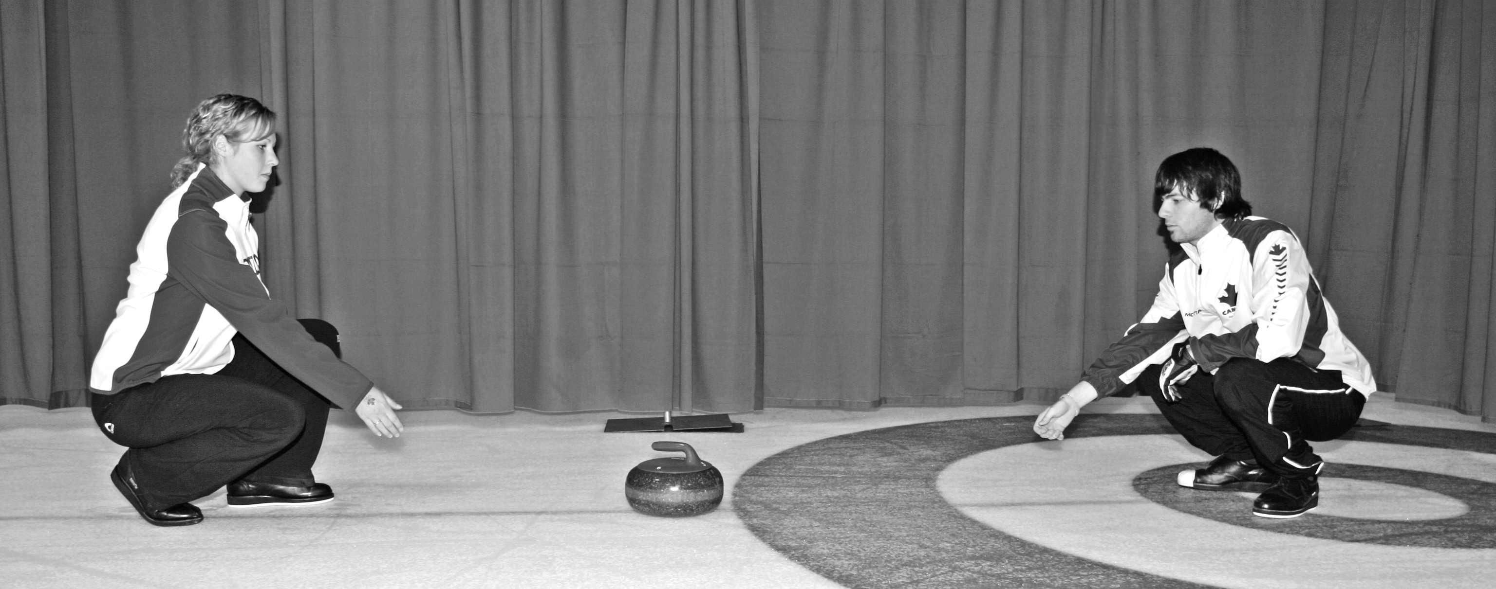

- Strategic Decisions

Modified Curling Game – “The Short Game”
Objective: Assist Curlers in strategy discussions and aid them in learning about angles/how stones react when they strike each other.
Instructions: Curlers can play as individuals or equal number of teams (ie. 2 on 2, etc…) Curlers throw from the hack towards the “throwing” house, (house immediately in front of them). Rules: Double Grippers, must keep one foot in a hack while throwing. Traditional curling scoring.
Variation: Have Curlers throw from just outside the playing hog-line, this will then involve the Free Guard Zone, throwers must keep one foot touching the centre line while delivering. Alter rules – ex. No removal of rocks, let the Curlers make up the rules!

- Fun way to Train

Modified Curling Game – “Bocce Curling”
Objective: To add variation to the traditional rules of curling, improve strategic thinking, weight control and teamwork.
Instructions: Two curling teams play each other from separate ends of the ice. Each team has their eight coloured stones at their end with them. A coin toss determines which team gets to throw the “jack” or “pin.” A hockey puck or curling stone can be used (use a big stone, if your youth Curlers are throwing with “little rocks,” Use a little rock if your youth Curlers are throwing big rocks). The team that throws the “jack” must throw the stone between the two hoglines, not touching the sidelines. The jack gets moved to the centre line at the same latitude on the ice. If the team is unsuccessful in throwing the “jack” (ie. Goes over the opposite hog line or over a side line) the opposition gets to throw the “jack.” The team which throws the “jack,” throws the first stone. The Jack becomes the new pin – the team with their stone(s) closest to the pin at the end of the end scores the point(s). Obviously the pin can be moved. If the pin leaves the area of play (between the two hoglines and sidelines), the pin is returned to the centre line midway between the two hoglines (all other rocks remain in their original position). Throwers must throw from the hack, but must not let their body cross the hog line. There are no brushers allowed.

